EKS with Private Node Group:-
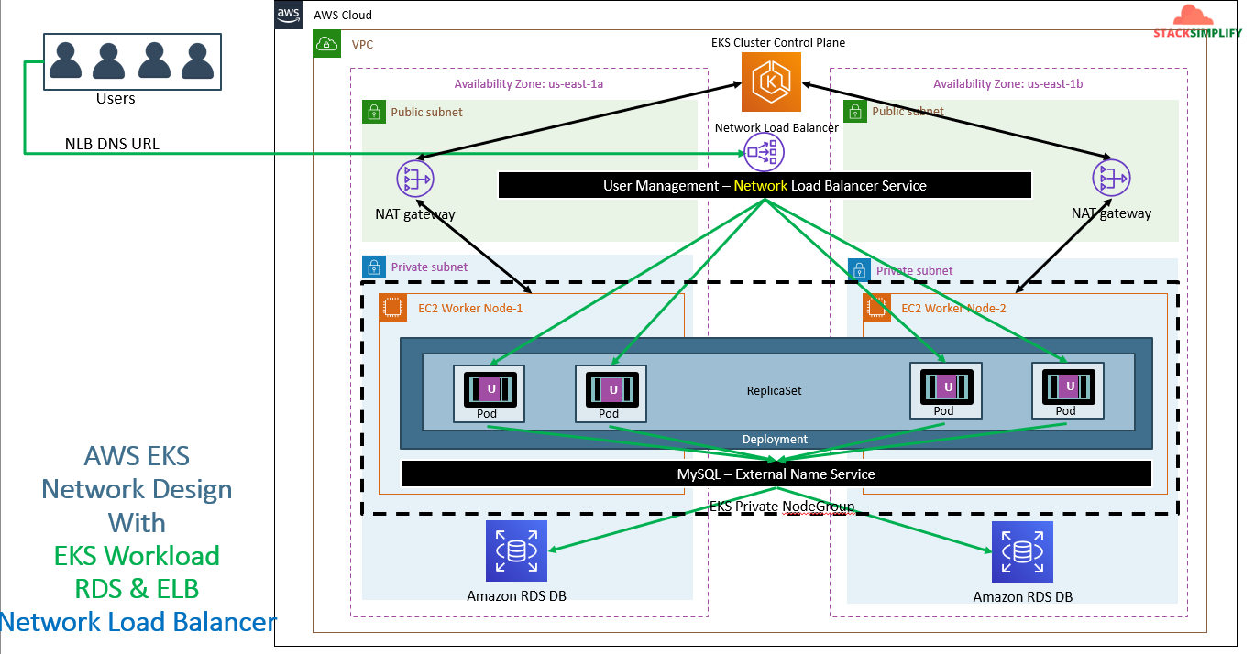
From above pic you can see our worker nodes are running in private subnet and our NAT Gateway is in public subnet. While LBs are in public subnet through LB we will access our app.
As a part of creating private node group first we will delete the public node group and we will create the new private node group.
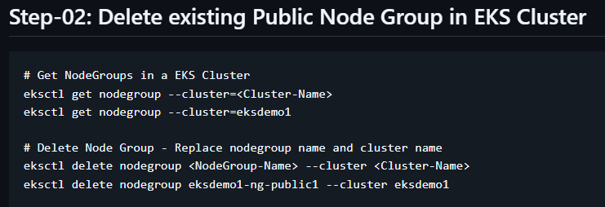
After deleting it
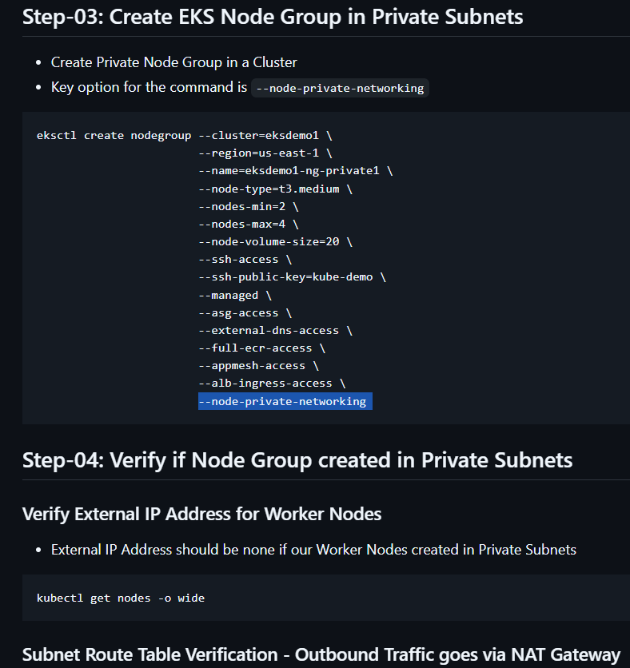
The kubelet will communicate with control plane via NAT Gateway.
- Verify the node group subnet routes to ensure it created in private subnets
  - Go to Services -> EKS -> eksdemo -> eksdemo1-ng1-private
  - Click on Associated subnet in Details tab
  - Click on Route Table Tab.
  - We should see that internet route via NAT Gateway (0.0.0.0/0 -> nat-xxxxxxxx)
EKS with Classic load Balancer demo:-
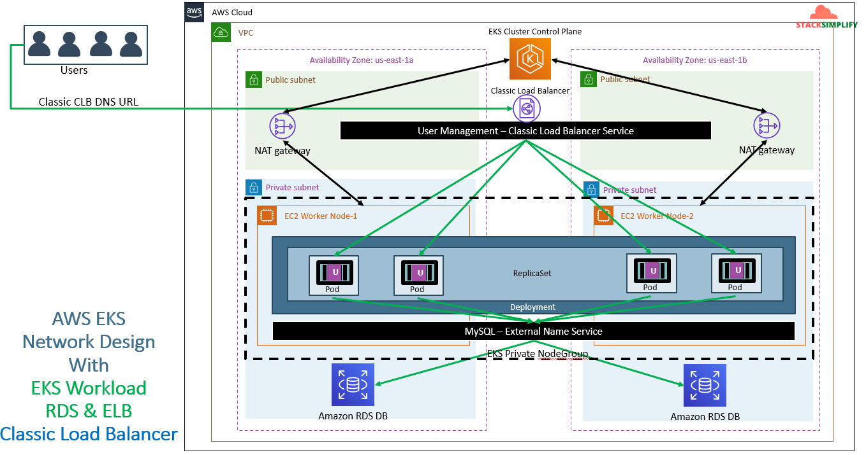
To access the traffic through standard http/https ports we need LBs. As a part of routing traffic we are using the Classic LB.
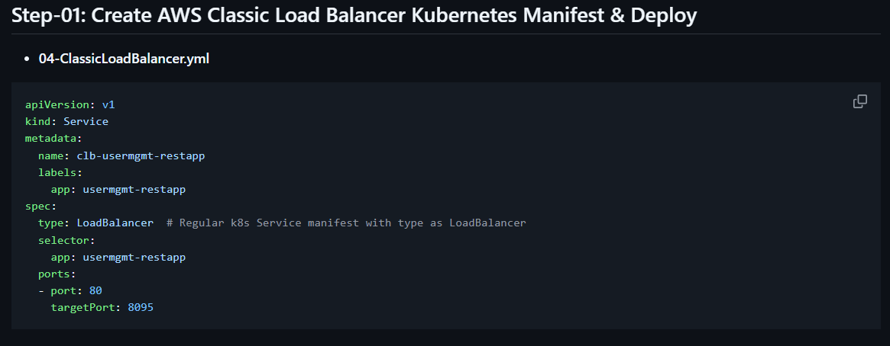
Copy all the manifests from previous RDS session except nodePort service and put it in sequence.
Run apply command.
Check for kubectl get svc.
Once pods are up check this “http://<CLB-DNS-NAME>/usermgmt/health-status” in browser.
Here our CLB-DNS-NAME is ‘a854c78b66f604c5ebeb062dc2840062-222479338.ap-south-1.elb.amazonaws.com’. The whole URL will look like ‘http://a854c78b66f604c5ebeb062dc2840062-222479338.ap-south-1.elb.amazonaws.com/usermgmt/health-status ’
To verify the communication with DB through Postman we can test this by creating users in RDS.
Verify in POSTMAN:-
We have already imported theses JSON scripts from previous session.
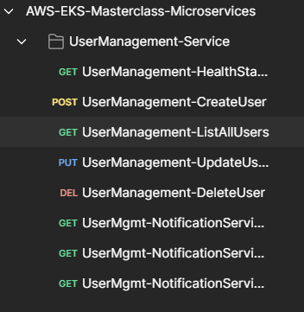
On top right side first we need to create an environment nothing but adding the LB’s URL.
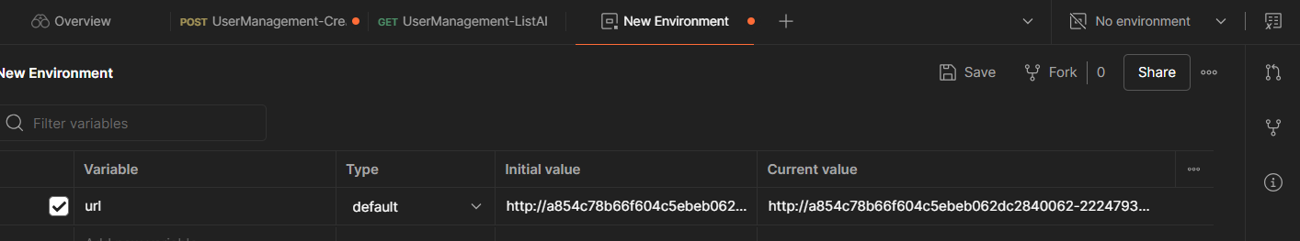
Once we configure it and save it.
Now click on ‘createUser’ script select the configured environment and click on send
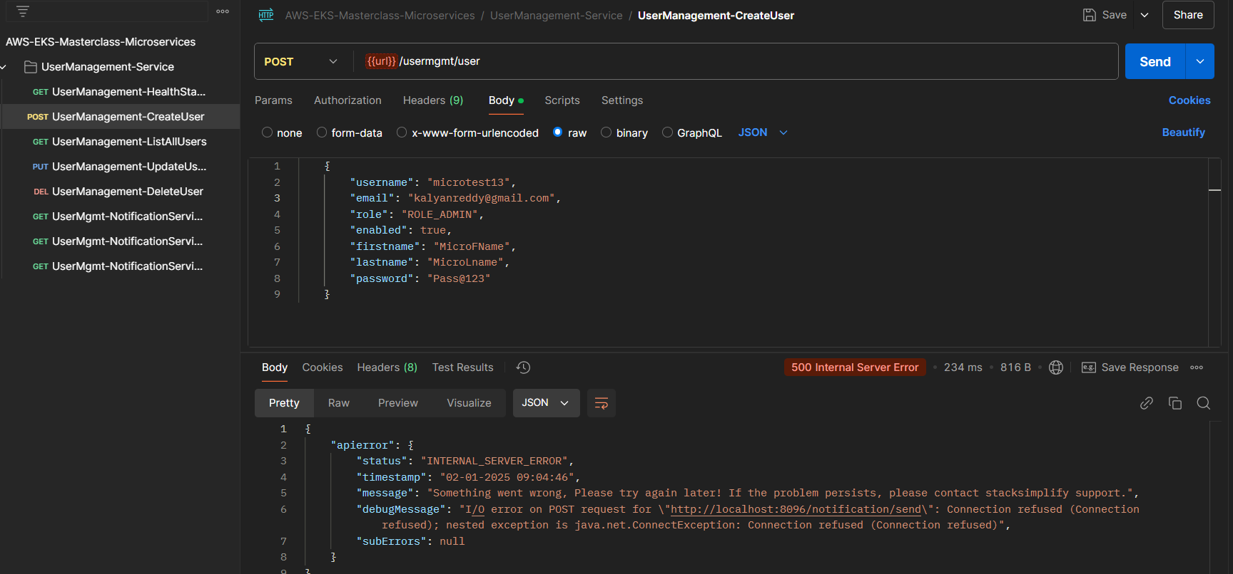
Same we need to got ListAllUsers click on send.
Whatever we have created an user in ‘CreatUser’ it will show here.
The complete entire flow is browser (accessing url) -> CLB -> PODS -> MysQL-External Name Service -> RDS .

Network LB:-
Nothing will change in the process compare to CLB only the change will be service manifest. We will add the annotation in our script like below
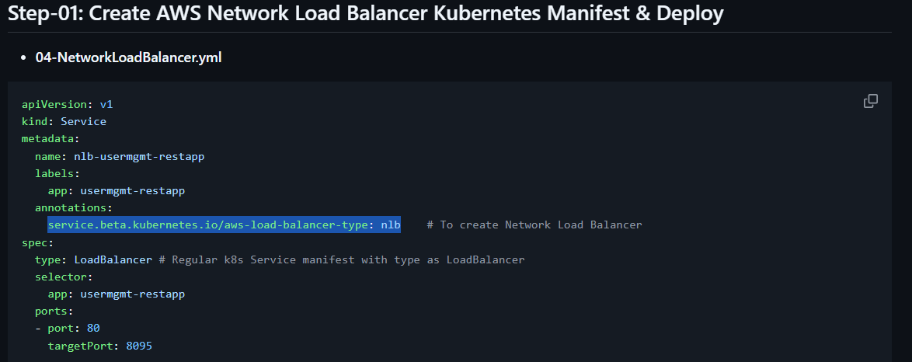
Once adding the annotations run apply command.
Check for kubectl get svc and verify the DNS name and verify whether NLB created in AWS console or not and then try to access it in browser.
If required verify in Postman.

